TSHIFHIWA MASHAPHA

ST10440428

MAST5112 POE PART 1 and 2

Below is the homepage of the restaurant. By the top left corner there is a navigation button which when you click should provide some information about the restaurant, for example, contacts so you can be able to make reservations. Below the restaurant`s name it should display a logo of the restaurant.

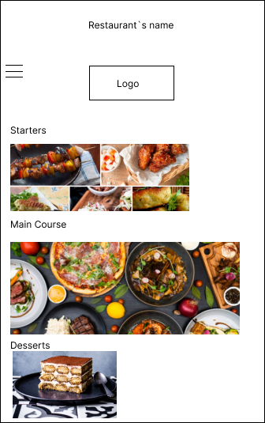

Below is the Chef`s login page where when he/she needs to change the menu will put their name and password then be able to change the menu for the day.

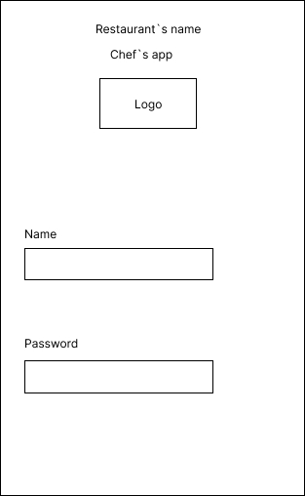

Below is the description page where the chef will be changing the menus, prices and what kind of food will be sold. So the Chef can change regularly what they are selling for the day and the description is to give more detail about what was used to prepare that specific dish that will be sold.

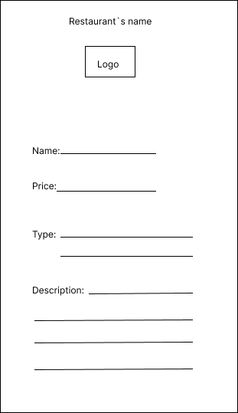

This page is where the chef will delete the previous menu when he/she wants to change the menu.

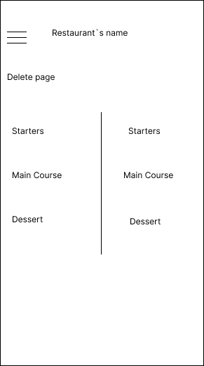

Below is the menu page where it will display all different kinds of food with their prices depending on what will be sold in that specific day, Chosen by the Chef.

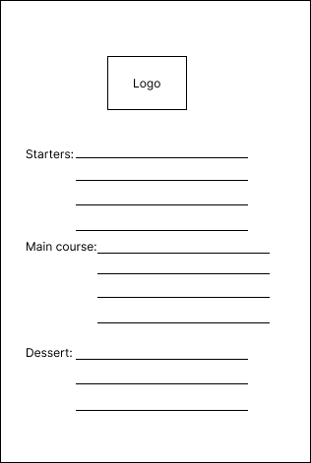

And lastly is the checkout page where you will be paying (this is more like a bill of what you have ordered). So, the customer will have to tick what he/she ordered then it will display the amount that is due for them to pay then click the checkout button.

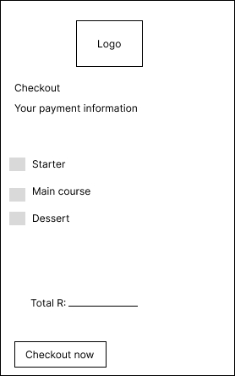

REFERENCING

<https://www.figma.com/design/IHCayTMjE3RlAZCY34ntZ8/Untitled?node-id=1-70&node-type=CANVAS&t=tt7M4gCAB4fuaMa0-0>

<https://www.olivemagazine.com/recipes/collection/easy-desserts-recipes/>

**PART 2**

This code is more focused on the homepage. The first 6 lines are declarations of the variables I am going to use in the code. This code was generated to create a homepage which a user can be able to enter their meal that they would like to eat and the price of that meal, and there is a button that can allow them to add more meals if they would like to. Therefore, when done placing your order there is a button that can take you to the next page which is the checkout where it will calculate the money due for the order you made.

For this code it makes the app easier for the user to use because you just must tick whether you would like to have starters, main course or dessert. So, it is optional what you want to have so all you must do is tick the boxes near to what is there, whether its dessert or main course its your choice to make.

Here is the link to the github:

<https://github.com/Mashapha17/Part_2-MAST>